ECE312 Communication Networks

Ryan Oberlitner & Scott Cai

Project 1 – Socket Chat Program

Screen captures

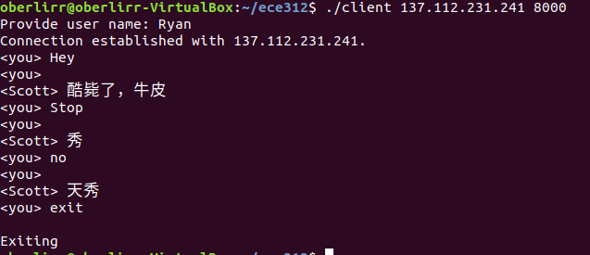

Figure 1This is the client side of the program.

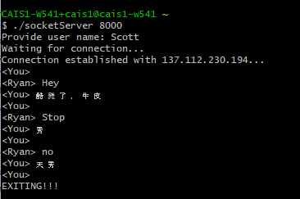

Figure 2This is the server side of the program.

Question

Consider how you would implement the application to allow more than two people to chat at once. In this group chat, nay message from one user should go to all users.

In order to implement more people connecting into this group chat, we need to add them as multiple clients withholding only one server. We also need to consider about socket changes for multiple people communication. Currently, the socket only allows two terminals connecting and communicating with each other, rejecting any other more terminals in. We probably need a main socket, and some other child sockets depending on how many clients in that multiple communication.